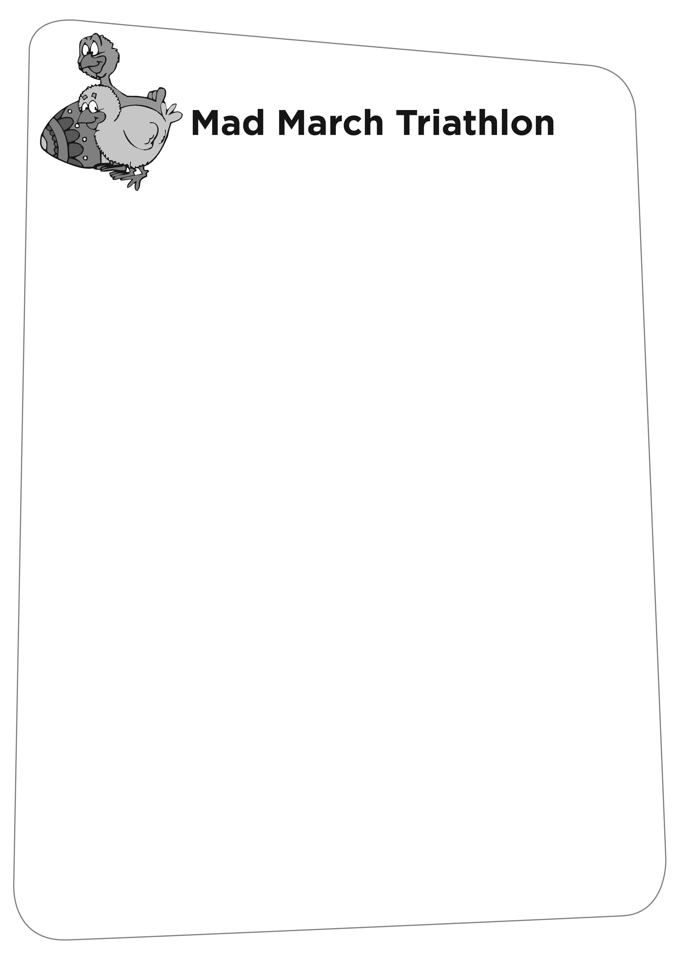

ADULT RESULTS 08

37. SJ MOORE 1.13.47
38. ROBIN WARREN 1.20.31
39. JASON BRILEY 1.15.03
40. JOEL NURSER 59.19
41. MARK FREEMAN 1.16.06
42.
43. MARK BRANFORD 1.00.26
44. AMALA HAWKER 1.08.32
45. ROSY MURRAY 55.07 1st Lady
46. ROB HAMMOND 55.47
47. STEVE BIRTWISTLE 49.12 2nd Male
48. DAVID FREEMAN 52.04
49. MARK ALDERSON 1.05.02
50. JOSEPH COOGAN 1.06.04
51. NICK ROBERTSON 59.15
52. JULIE HILLIER 1.19.06
53. ROB GALE 1.10.54
54. ALAN DOUGAL 57.47
55. PETER HARVEY 1.17.37
56. JAMIE BULL 1.06.42
57. SIMON NAVIN 1.02.36
58. ROBERT PETRIE 1.02.13
59. FRAN BUNGAY 56.33 2nd Lady
60. MICHAEL COURAGE 1.02.58
61. NICK SOUL 1.07.03
62. LORNE EMPSON 54.46
63. DAVE MCWILLIAM 1.00.28
64. NIGEL BRAIN 51.57
65. JENNY BRAIN 1.06.37
66. MIKE WARREN 1.23.37
67. BECCA WARREN 1.22.15
68. ROBERT BRENNAN 1.21.05
69. RICHARD MESTON 1.10.26
70. CULVIN MILMER 1.01.01
71. GRAEME BEESON 1.02
72. HOWARD SPRIGGS 1.00.18
73. JO BICKNELL 1.29.41

