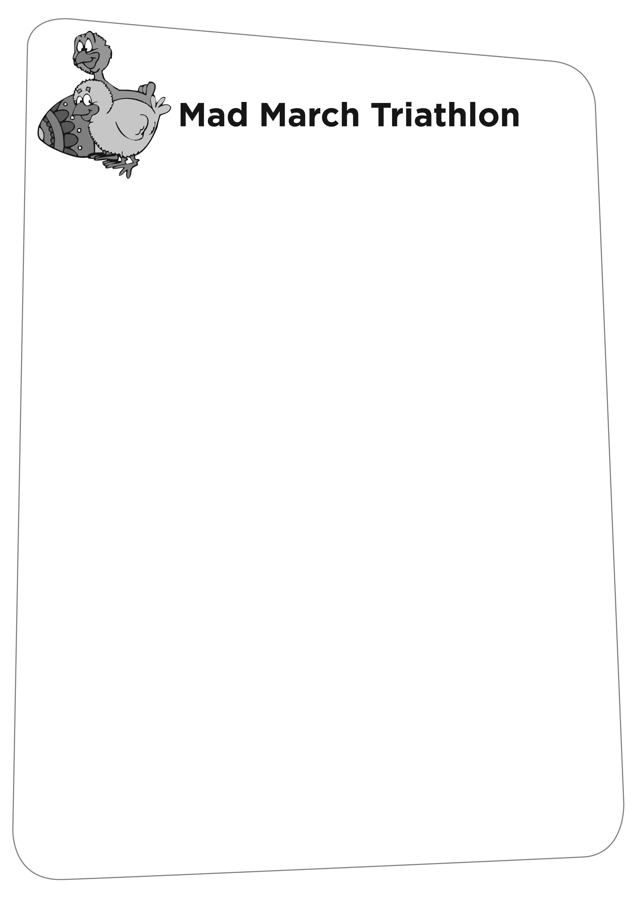

ADULT RESULTS 08

- JOHN COSTA 1.08.42
- EOIN SCOTT 1.00.41

- CLAIRE HARDING 1.10.49
- KEVIN HARDING 53.11
- NICOLA LEWIS 59.30
- MARK POOLE 1.13.16
- LYNDA WEMYSS 1.23.35
- FAITH FOOTE 1.23.34
- LEE WILLS 1.09.39
- DENNIS PALMER 1.09.38
- STUART HARRISON 1.32.49
- SARAH WHEELER 58.36 3rd Lady
- JOHN WOOD 55.16

- MILES TARPEY 1.18.19
- LEE OSBORNE 1.33.29
- HESTER MORTIMORE 1.26.00
- RICHARD ANDERS 57.46
- MICHAEL BARTON 49.50 3rd Male
- CHRISTIAN HUGHES 1.11.34
- NICHOLAS SPENCER 1.00.01
- STEPHEN CANAVAN 1.07.14
- GARY LARSEN 1.20.45
- RUSS CONWAY 51.47
- ANN LEWIS 1.06.24
- MATTHEW DOMINEY 1.03.42
- RONI MENIN 1.16.17

- GARY SMITH 1.05.43
- STEVE HUDSON 1.13.26
- CLIFF RICE 1.03.11

- NEIL PINCH 1.00.06
- MARTIN LANGRAN 1.18.34
- BECKY KENNETT 1.17.04

