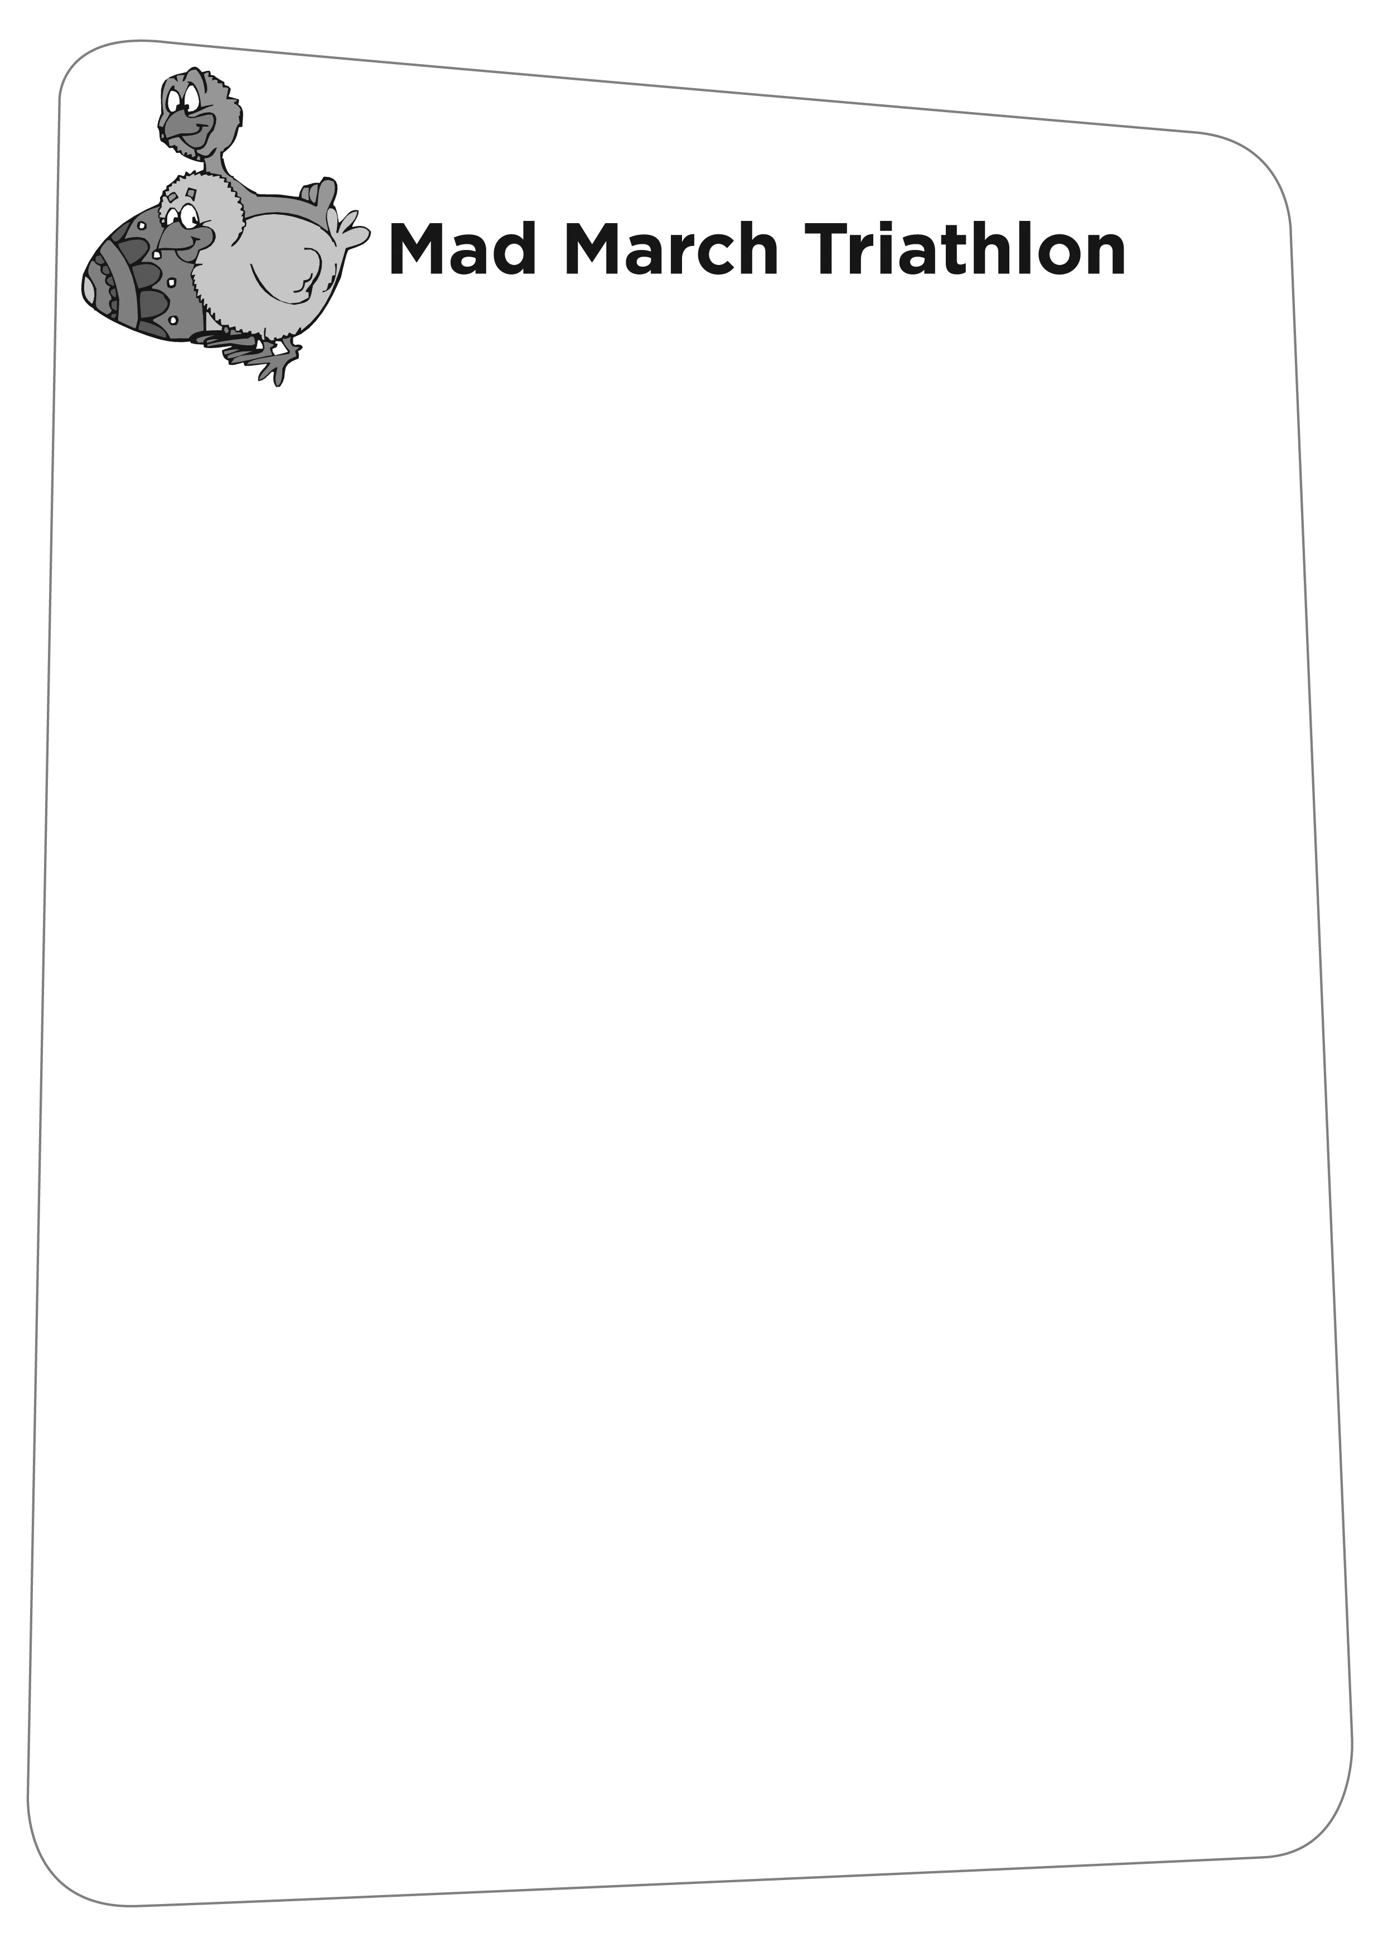
JUNIOR RESULTS 08

TRI STAR 3
16. KIM WHITTAKER 45.06
17. JAMES CARR 33.31
20. OLLIE WOMERSLEY 38.17
27. ELEANOR WEATHERILT 44.31
28. OLIVER SPRIGGS 30.30
33. MADDIE MORRIS 41.02
34. JACK SNOOK 31.51
35. JOSEPH WILLIAMS 30.45

YOUTHS A

- THOMAS LEWIS 37.48
- JESSICA FENNELL 38.38

